**Lab 4**

1. Consider the given bank database and formulate the given queries in SQL:

Customer (Ccode, Cname, Street, zip, hmtel, wktel)

Borrower (Ccode, Bname, Street, zip, hmtel, wktel)

Account (Acno, Ccode, Branch, Balance,Acttype)

Ac-actype(Acttype, Interest)

Transaction (Acno, tno, type, tdate, Issuedby, amt)

Loan (Lno, Bcode, branch, debit)

Loanpayment (Lno, paymentno, Pdate, issuedby, amt)

1. Find the names of the customers of the bank who have taken loans.
2. Find the codes and the balances of the customers who have accounts the balance of which is greater than the average balance of all the accounts in the bank.
3. Find the name of the customer who owns the account with code 00001.
4. Find the names of the customers who own accounts which pay no interest or which are held at the branch 20002.
5. Retrieve the names of the customers, whose accounts had a
6. transaction on the 10th of September 1995.

Find the names of the customers who have accounts whose balance is higher than the average account balance in the bank.

1. Consider the logical schema given below. Create tables based on it, insert appropriate data and answer the following queries:

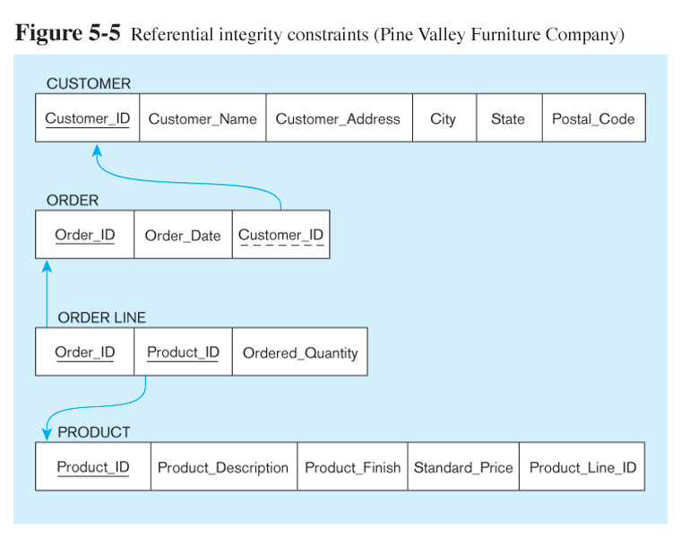

While creating product table, check whether the product_finish is cherry,

natural ash, white ash, red oak, natural oak or walnut.

1. Show product id and finish for all products

2. Show product id and finish for all products, sort by product_line_id by ascending order

3. Show product id and finish for all products, sort by product_line_id by descending order

4. Show each product_line_id and the total number of products for the product_line_id

5. Show product_id and description for all products whose names contain a string of "table"

6. Change a product_description from 'Duplex Table Lamp' to 'Arch Table Lamp'

7. Show dates and how many orders received in each individual day